

Draw It or Lose It

# **CS 230 Project Software Design Template**

Version 1.0

## Table of Contents

**CS 230 Project Software Design Template**1

**Table of Contents**2

**Document Revision History**2

**Executive Summary**3

**Design Constraints**3

**System Architecture View**3

**Domain Model**3

**Evaluation**3

**Recommendations**5

## Document Revision History

| Version | Date | Author | Comments |
| --- | --- | --- | --- |
| 1.0 | 04/18/21 | Andrew Wepplo | Design and evaluate a game program for the client |

**Instructions**

Fill in all bracketed information on page one (the cover page), in the Document Revision History table, and below each header. Under each header, remove the bracketed prompt and write your own paragraph response covering the indicated information.

## Executive Summary

The client would like to find the best platform to handle the software requirements to make the process of a guessing game that allows all team members to see a puzzle that is rendered for all players and gives a specific time limit to present a guess before time expires. The team will develop a non-mobile version of the game, that will have one or more teams with options for customization, and keeping it as streamlined as possible to only allow one instance of the game to exist at any given time.

## Design Constraints

The constraints of turning this mobile based app into a web-based app and changing some parameters may cause some of the specific rules to change, it cannot all just be copied and pasted. The UML diagrams, and class diagrams in development will be different and may not create an exact match after transferring to a new interface, in the end the application will be able to complete the requirements wanted by the client but it may take a different path to reach that goal than originally planned

## System Architecture View

Please note: There is nothing required here for these projects, but this section serves as a reminder that describing the system and subsystem architecture present in the application, including physical components or tiers, may be required for other projects. A logical topology of the communication and storage aspects is also necessary to understand the overall architecture and should be provided.

## Domain Model

The UML diagram shows a clear example of object-oriented programming, with inheritance. The Entity class is the parent class where it is linked by association to the following four classes; GameService, Game, Team, and Player. Each of these listed classes depend on one another, but the ProgramDriver is the main class and is linked to the SingletonTester class to allow it to perform inherited activities from the main class.

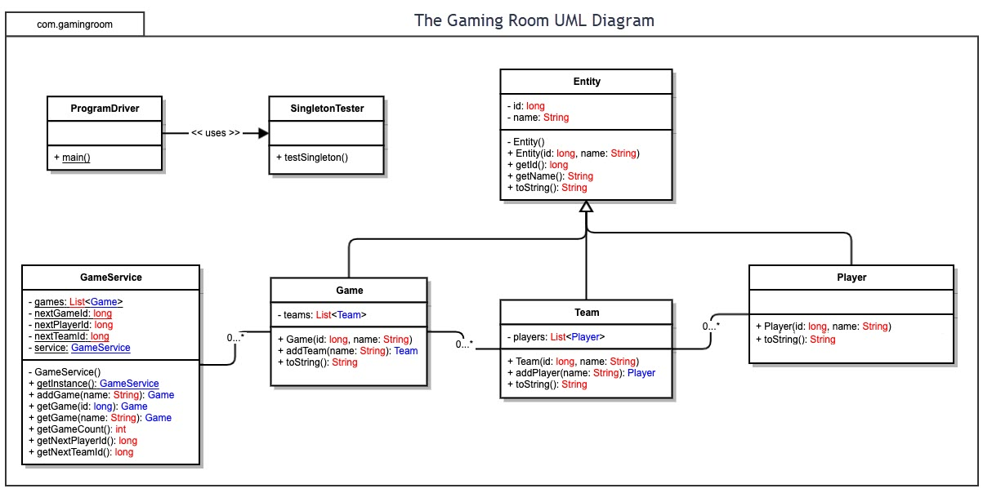

## Evaluation

Using your experience to evaluate the characteristics, advantages, and weaknesses of each operating platform (Linux, Mac, and Windows) as well as mobile devices, consider the requirements outlined below and articulate your findings for each. As you complete the table, keep in mind your client’s requirements and look at the situation holistically, as it all has to work together.

In each cell, remove the bracketed prompt and write your own paragraph response covering the indicated information.

| **Development Requirements** | **Mac** | **Linux** | **Windows** | **Mobile Devices** |
| --- | --- | --- | --- | --- |
| **Server Side** | Characteristics:  Growing in popularity due to web hosting capabilities Advantages:  Has more intuitive software and design  Weaknesses:  It is less commonly used, and comes at a price | Characteristics:  Most secure Advantages:  Most preferred of all listed due to security of web hosting  Weaknesses:  It is less commonly used, and hardware drivers are not as readily available | Characteristics:  Most widely used Advantages:  High level of experience among users, cheaper hardware  Weaknesses:  Vulnerable to viruses, and must keep up with virus software and could cost in long run | Characteristics:  Portable, most popular and accessible Advantages:  Can reach a larger portion of the population, no addition cost associated  Weaknesses:  Smart phone market is vast, and physical security is lacking |
| **Client Side** | Specialty raining will be required for the development, and less clients may be willing to pay the premium for the hardware. | Lack of widespread use will be a problem, not as popular as the other options, and expensive | Most commonly used, less training time, cheaper than other choices | Most commonly accessed, high level of technical support, hardware is upgraded regularly by users without need for pressure |
| **Development Tools** | Eclipse, Xcode, Visual Studio Code | Eclipse, Git, Atom, NetBeans | Java, Python, C++, NetBeans | Android Studio |

## Recommendations

Analyze the characteristics of and techniques specific to various systems architectures and make a recommendation to The Gaming Room. Specifically, address the following:

1. **Operating Platform**: Windows would have to be the recommended OS for the web-based software with being much more compatible that Mac and cheaper in terms of Hardware.
2. **Operating Systems Architectures**: The architecture is based on two main components, user mode and kernel mode. Kernel mode has full access to the hardware of the computer while the user mode is more limited and can be restricted from accessing certain areas of the operation system by the kernel mode but that should not even come into play with an application like this.
3. **Storage Management**: Windows would be compatible with a database management system for its storage. And it would be the most efficient overall with its adaptability.
4. **Memory Management**: The software for this game will cause the Windows operating system to put large portions of its RAM towards using the application and could even get temporarily stored on the HDD if the amount of memory required exceeds the installed RAM of the unit.
5. **Distributed Systems and Networks**: The best system to run this type of networking would be LAN, it is the most reliable and allows for protection of there is an outage or in the event of a crash. And with the ability the have a hub that can magnify the signal, it can sustain maximum connectivity.
6. **Security**: Although windows does have one of the higher possibilities of breach, this can be mitigated with virus protection/security software. To make sure that all of the applications personal information is protected.